First Wish Art Gallery LLC, Georgia 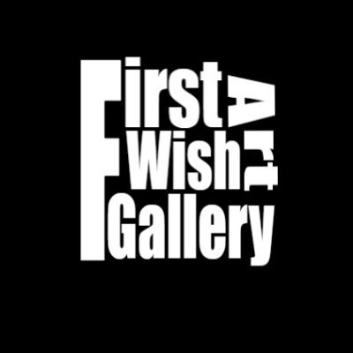 ARTIST CONTACT INFORMATION
*Artist Name:
*Date of birth (DD/MM/YYYY):
*Address:
*Short Bio:
Artist Nationality
(country the artists are originally from):
*Mobile Number:
*E-mail:
*Website:
*All Social Media Handles:
- Instagram
- Facebook
- Twitter
- LinkedIn
*Details of other participated exhibitions & events
*Artist Profile Picture: | To be attached separately in the email
*Photos of artwork with details (Art work name, Size - H x W , Medium) | Photos must be attached separately in the email

Bank account details for registration fee 10 USD:
- Beneficiary’s Bank: JSC TBC Bank
- Bank Code: TBCBGE22
- Beneficiary’s IBAN: GE42TB7298945067800007
- Name of Beneficiary: First Wish Art Gallery LLC

- Paypal account - https://paypal.me/firstwishartgallery

Once you make the payment, pls share receipt on email mentioned as below

For any further details, please do not hesitate to contact us:
- Ms.Mariami Simashvili : +995 598943400 | mariam@firstwishartgallery.com

- Mr.Irshad Husain : +971 527786166 | irshad@firstwishgroup.com

